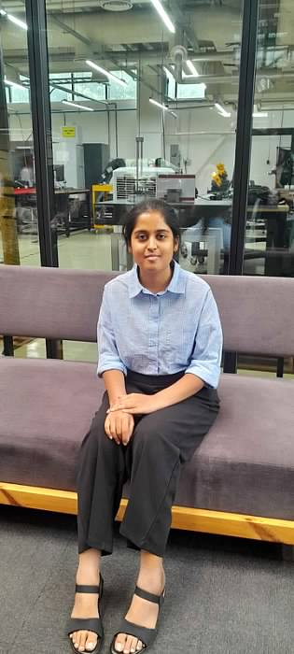

Gnaneshwari Mahimaluru
PGBA25002
PGDM -BA
SOIM - GNITS

Industrial Visit Report
T–Hub, Hyderabad
Date of Visit: 12th August 2025

1. Introduction
The industrial visit to T–Hub, located in Raidurg, Hyderabad, Telangana, was organized to provide students with practical exposure to the startup ecosystem, innovation culture, and entrepreneurship support systems in India. T–Hub serves as a platform that connects startups, corporates, investors, and academia to foster innovation and growth.

2. About T–Hub
T–Hub is an innovation intermediary and business incubator established in Hyderabad, Telangana. It operates on the Triple Helix model of innovation, which is a synergy between government, academia, and industry. The three academic institutions that partner with T–Hub include:
- Indian Institute of Technology, Hyderabad (IIT-H)
- International Institute of Information Technology, Hyderabad (IIIT-H)
- Indian School of Business, Hyderabad (ISB)
Launched in 2015, T–Hub has become one of India's leading innovation ecosystems, supporting startups at various stages and offering access to mentors, funding, infrastructure, and market opportunities.

3. Objectives of the Visit
- To understand the functioning and ecosystem of a business incubator.
- To learn about startup development and innovation support.
- To interact with industry experts and startup founders.
- To explore potential career or entrepreneurial paths.

4. Key Takeaways from the Visit
- Startup Ecosystem: We learned how T–Hub supports early-stage and growth-stage startups through incubation, acceleration programs, and mentorship.
- Triple Helix Model: The integration of government support, academic research, and industry involvement creates a robust foundation for innovation.
- Infrastructure: T–Hub offers state-of-the-art co-working spaces, event areas, meeting rooms, and labs designed to encourage collaboration and creativity.
- Networking and Mentorship: The center regularly hosts events, hackathons, and workshops that connect startups with investors, corporates, and mentors.
- Success Stories: We were introduced to various startups that successfully scaled through T–Hub’s support, showcasing real-world impact.

5. Student Experience
During the visit, students were given a guided tour of the facility and participated in an interactive session with T–Hub representatives. We gained insights into the innovation process, the lifecycle of a startup, and how T–Hub assists in overcoming challenges in entrepreneurship.

6. Conclusion
The industrial visit to T–Hub was an enriching experience that broadened our understanding of the startup ecosystem and innovation support mechanisms in India. It inspired many of us to consider entrepreneurship as a viable career option and highlighted the importance of interdisciplinary collaboration in driving innovation.

7. Acknowledgement
We express our sincere gratitude to the management of T–Hub for hosting us and providing valuable insights. We also thank our college administration and faculty coordinators for organizing this informative visit.
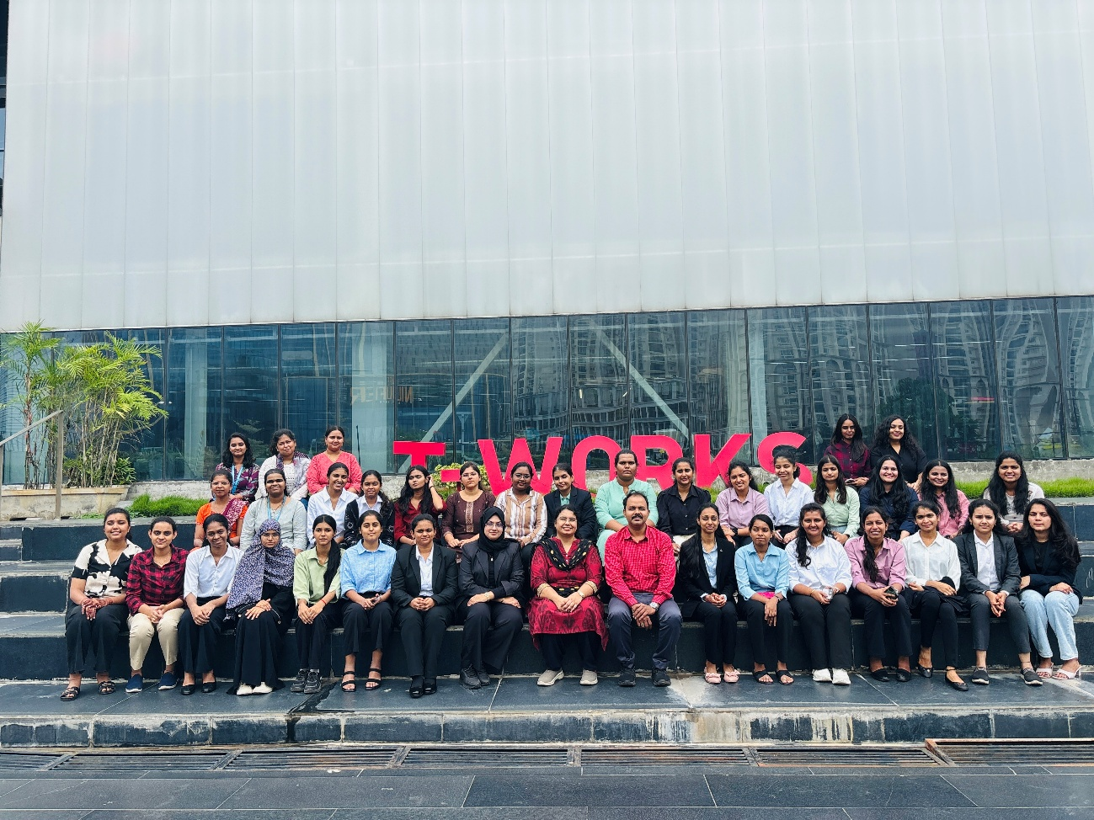

This is the Group Pic that has been taken after visiting the T-Hub

